PROJECT: ANALYZE THE HEALTHCARE COST AND UTILIZATION IN WISCONSIN HOSPITALS

FOR IMPORTING DATASET
> dataset <-read_excel('1555054100_hospitalcosts.xlsx')
> View(dataset)

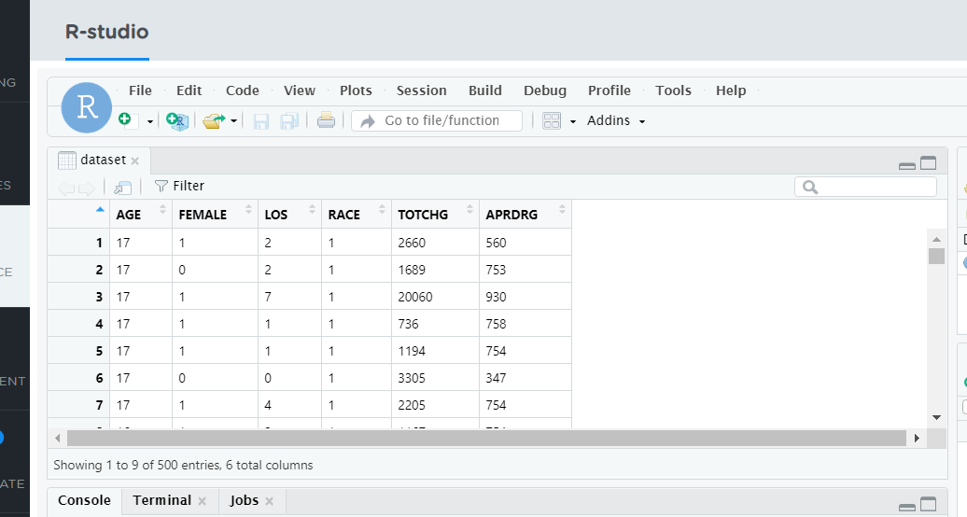

- PART 1
To record the patient statistics, the agency wants to find the age category of people who frequent the hospital

R CODE
table(dataset$AGE)
hist(dataset$AGE)

Output Screenshot
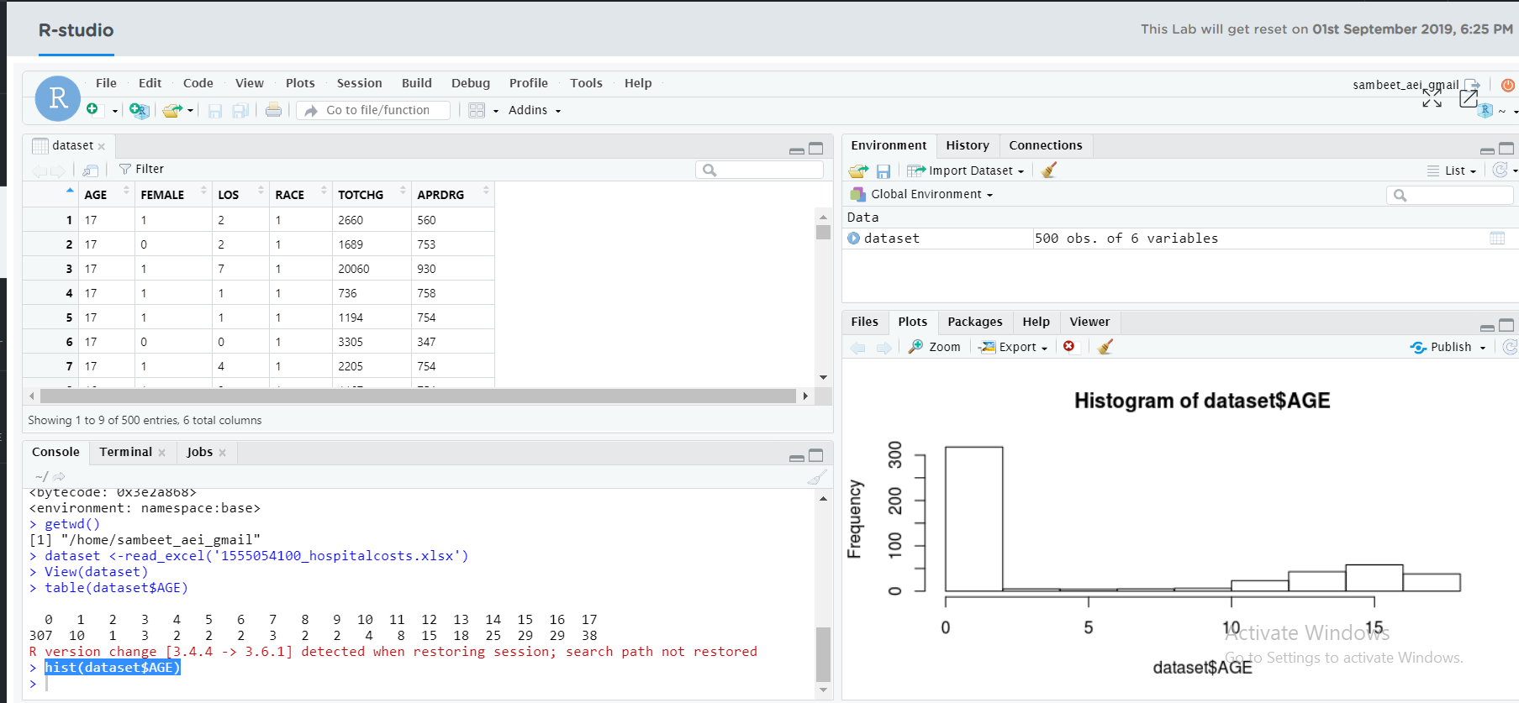

INSIGHT
It is clearly both in the histogram and frequency that the age group which frequent the Wisconsin Hospital are of age 0 or newly born infants where the number (that is 307) is much larger than any other age
PART 2
Age with maximum expenditure
R CODE
aggregate(TOTCHG~AGE,FUN=mean,data=dataset)
max(aggregate(TOTCHG~AGE,FUN=mean,data=dataset))

OUTPUT SCREENSHOT

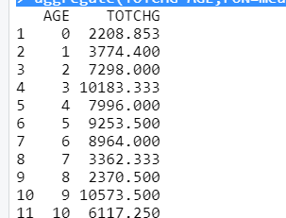

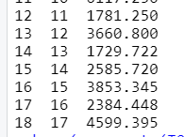

INSIGHT

Children with 9 years have the maximum mean Total Expenses that is 10573.5, followed by children with 3 years of age (10183.33)

2> PART 1

In order of severity of the diagnosis and treatments and to find out the expensive treatments, the agency wants to find the diagnosis related group that has maximum hospitalization

R CODE
aggregate(LOS~APRDRG,max, data=dataset)

OUTPUT SCREENSHOT
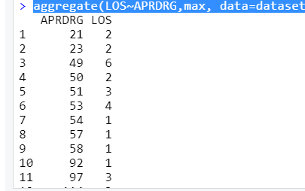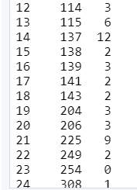

INSIGHT

Diagnosis no 602 has the maximum hospitalization days (that is 41) followed by diagnosis no 421(39 days)

PART 2
Diagnosis related group with max expenditure

R CODE
aggregate(TOTCHG~APRDRG,max, data=dataset)

OUTPUT SCREENSHOT
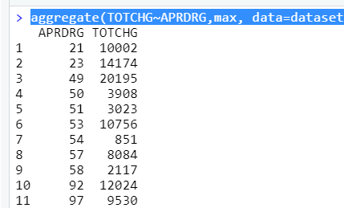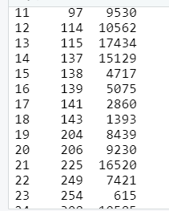

INSIGHT
Diagnosis no 911 has the maximum hospitalization expenditure (that is 48388) followed by diagnosis no 602(Rs. 29188)

3>
To make sure that there is no malpractice, the agency needs to analyze if the race of the patient is related to the hospitalization costs.

R CODE

> hospna<-na.omit(dataset)
> modelannova<-aov(TOTCHG~RACE,data=dataset)
> summary(modelannova)

OUTPUT SCREENSHOT

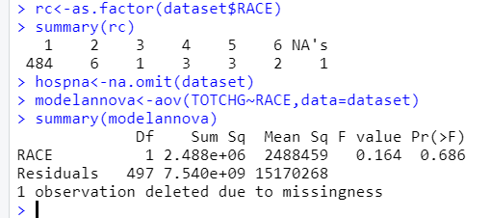

INSIGHT
h0: The race of the patient is related to the hospitalization costs.
ha: no relation
p value comes out to be very high 68% this means we can take risk and reject the null hypothesis this means there is no relation between the race of patient and the hospital cost.
4>
To properly utilize the costs, the agency has to analyze the severity of the hospital costs by age and gender for proper allocation of resources
R CODE
aggregate(TOTCHG~AGE+FEMALE,mean,data=dataset)
> m1<-lm(TOTCHG~AGE+FEMALE,data=dataset)
> summary(m1)

OUTPUT SCREENSHOT
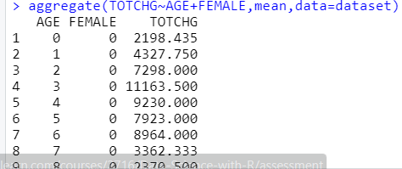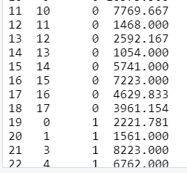

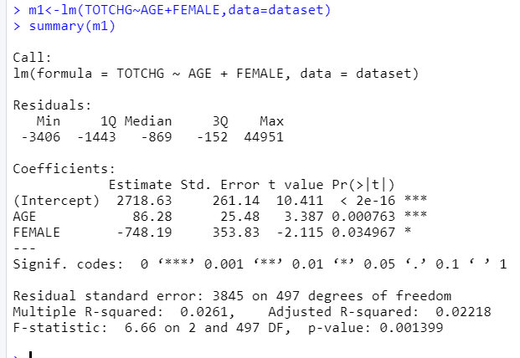

P value for age is very less this means it is an important factor in the hospital costs. Gender has also less p value means it is also having the impact on cost and same with intercept
5>
Since the length of stay is the crucial factor for inpatients, the agency wants to find if the length of stay can be predicted from age, gender, and race.
R CODE
> m2<-lm(LOS~AGE+FEMALE+RACE,data=dataset)
> summary(m2)

OUTPUT SCREENSHOT
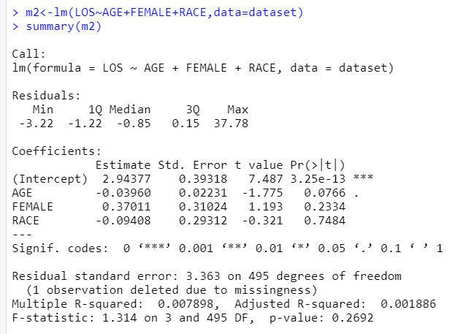

INSIGHT
A very high p-value signifies that there is no linear relationship between the given variables. That is, with just the age, gender, and race, it is not possible to predict the stay of a patient
6>
To perform a complete analysis, the agency wants to find the variable that mainly affects the hospital costs.

R CODE
> m3<-lm(TOTCHG~ .,data=dataset)
> summary(m3)

OUTPUT SCREENSHOT
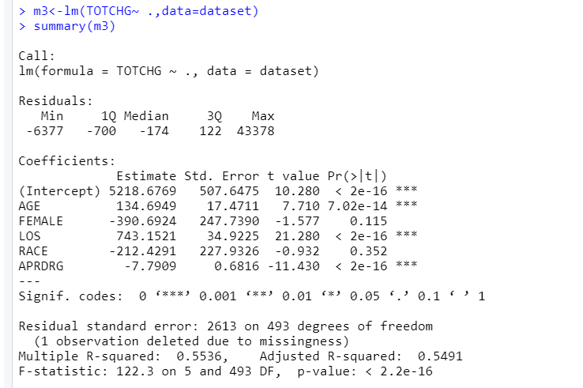
INSIGHT
Age,length of stay, APRDRG affect the total hospital cost as per p value

